Implementation of Majoo-Based Supply Chain Strategy to Improve Quality and Efficiency of DIY Kits at AT Studio

Suyanti,*, Immanuel Zai²

¹University International Batam, 2141037.suyanti@uib.edu, Batam City, and Indonesia
²University International Batam, Immanuel.zai@uib.edu, Batam City, and Indonesia

Abstract. AT Studio is a nearby craft studio that specializes in innovative handcrafted goods. This studio has steadily expanded over the years and is widely known for its dedication to high-quality craftsmanship. This project focuses on improving operational efficiency at AT Studio through the implementation supply chain strategy using Majoo system. The process begins with manually recording stock data on a spreadsheet, followed by transferring this information into the Majoo system. All implementation activities with AT Studio partners show positive results, after the implementation of detailed product stock recording and the accuracy of stock data recording also show positive results.

Keywords: Supply Chain Management; Inventory Tracking; Majoo Application; AT Studio; DIY kit; Batam City

- Introduction
AT Studio is a nearby craft studio that specializes in innovative handcrafted goods. This studio has steadily expanded over the years and is widely known for its dedication to high-quality craftsmanship, especially in the areas of crocheting, batik painting, resin, and other creative arts. Additionally, AT Studio is well-known for its highly customized and individualized designs that appeal to both domestic and foreign consumers. AT Studio is open Tuesday through Sunday from 11:00 AM to 9:00 PM WIB and AT Studio is located in Ruko Mitra 2 Block B2-13, Batam Centre, Batam City. AT Studio is ideally situated close to foreign markets like Singapore and Malaysia. A lot of visitors frequently visit AT Studio to engage in handicrafts and recreation. In addition to providing personalized handicrafts, AT Studio’s operational activities include offering DIY kits, which are collections of handicraft products that clients can make anywhere. The required equipment and supplies, along with detailed instructions for finishing handicrafts like crocheting, embroidery, and other hand arts, are included in every DIY kit that is offered. The goal of this DIY Kit idea is to allow users to express their creativity wherever they are while still following the growing popularity of handicrafts.
AT Studio is a craft studio that focuses on the production of handmade goods, with a significant need for inventory management. The production process relies on various materials, such as threads, yarns, and other crafting tools, which necessitates efficient and accurate inventory management (Pasaribu, 2021). One of the primary issues that arises from the absence of inventory recording is the inaccuracy of inventory recording that is not connected to the purchasing procedure, manufacturing material usage, and final product sales (Zhang et al., 2021). Furthermore, using a manual or traditional approach to inventory tracking raises the possibility of human error or mistakes being made when documenting the input and outflow of items. Because the required raw materials are not readily available, this might slow down the production process and result in lengthy production delays (Sgarbossa et al., 2020). It can also have an impact on the quality of customer orders (Agboola et al., 2022)
As the activities of AT Studio become more complicated, AT Studio has started to see the value of having more integrated and structured system to track inventory (Putra et al., 2023). Thus, it is anticipated that the Majoo-based supply chain approach will aid in resolving the current problems (Harjanti, 2024). In the long run, it will be expected that the Majoo system would increase studio operations’ efficiency and offer real-time information (Putra et al., 2024). By using a digital system based on Majoo, the supply chain management strategy implementation project at AT Studio aims to increase inventory management transparency, user efficiency in recording product stock, and accuracy in recording products inflow and outflow. The Majoo app also assists in displaying different product-related data that partners require (Siskawati et al., 2024). The advantage for partners is that they can reduce production delays by managing inventory with a more structured and transparent flow (Sudiantini et al., 2023).

- Literature or conceptual review
The targets of this project include inventory data accuracy up to 95%, reduction of manual recording errors by up to 90%, real-time inventory monitoring, a 50% reduction in inventory recording processing time, smooth system implementation by staff, reduction of production delays due to stock shortages, and overall improvement in operational efficiency.
In this project, several key outputs have been produced that support the achievement of the project’s goals. The project outputs include:
- An inventory management system that is connected to the Majoo app: with raw material and finished goods inventory data entered into the system, the Majoo application setup has been adjusted to meet AT Studio’s requirements.
- Updated inventory data: The Majoo system now contains stock data for raw materials, completed goods, and things in the production process that were previously kept in manual records.
- Regular inventory reports: The Majoo system may automatically generate inventory reports that include minimum inventory levels, stock turnover records, and information on raw materials that require reorders.
- A guide to using the Majoo system: An AT Studio-specific usage manual for the Majoo application that covers how to track material usage, record stock, and create reports.
- User training: AT Studio employees received instruction on how to use the Majoo application for inventory management in accordance with the developed guide sheet.

- Research design
The data collection techniques used in this activity include several methods to obtain data that supports research and implementation. Attempting to collect more specific information about the needs od the business partners by conducting surveys through interviews with their owners (Sugiyono, 2019). Then, conduct observations related to the supply chain management of AT Studio with the aim of understanding and recording how the supply chain management procedures of the business partner work. The data gathering results show that AT Studio’s supply chain management is still unstructured and needs a more effective system to save expenses for the business as well as a suitable solution for transparent and real-time inventory recording.

- Results
  - Implementation Process
The process of output implementation that has been carried out through several planned stages is as follows:

    - Equipment and Supplies for Manual Recording
AT Studio began by manually recording the tools and materials available at the partner’s site using a spreadsheet in order to facilitate the implementation of inventory management in the Majoo system. In order to make the recording more structured and ordered, SKU classification for the tools and materials was then added. The amount of tools and materials that are still in stock at AT Studio location can then be determined.

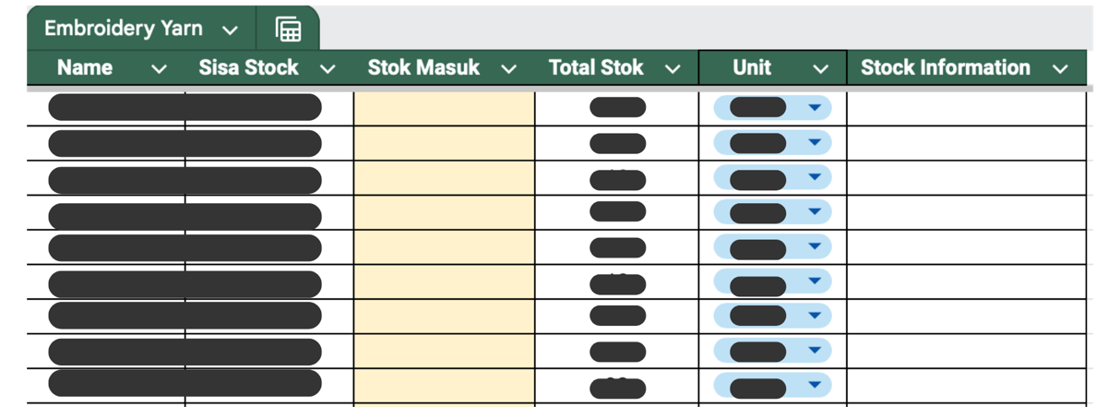
Figure 1 Manual product stock recording
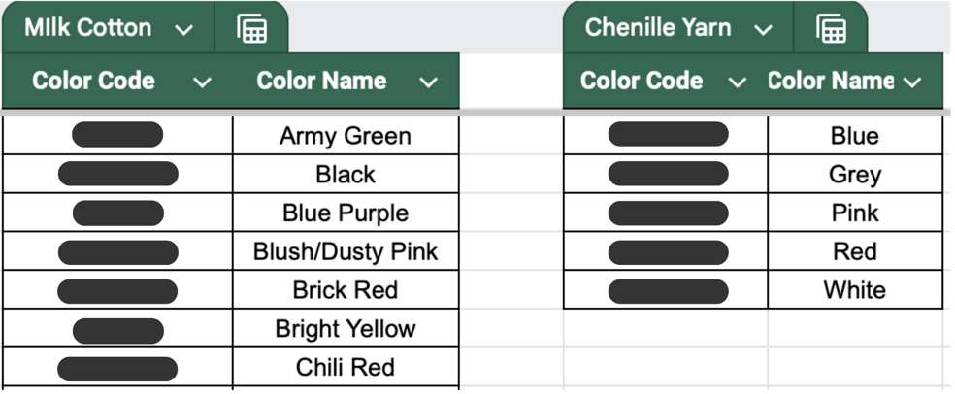
Figure 2 SKU classification on products

    - Recording DIY Kit Formulas
Each DIY Kit variant, such as crochet, tote bag painting, and resin DIY Kit, has it own unique formula or recipe. Therefore, to simplify the operational process of producing a DIY Kit, it is made easier by recording the formulas or recipes for each DIY Kit variant on the same spreadsheet page as the manual recording above. The formulas or recipes will be recorded based on what is needed in a DIY Kit variant along with the required measurement or units.

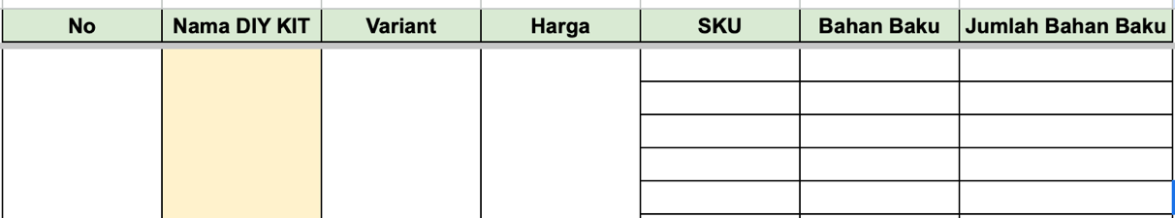
Figure 3 Manual DIY kit formula recording template

    - Inputting stock into the Majoo system
After manually recording it on the spreadsheet, this time it will be transferred to the Majoo system. Inputting the raw material used in the DIY Kit and also inputting the products per variant of the DIY Kit in the system.

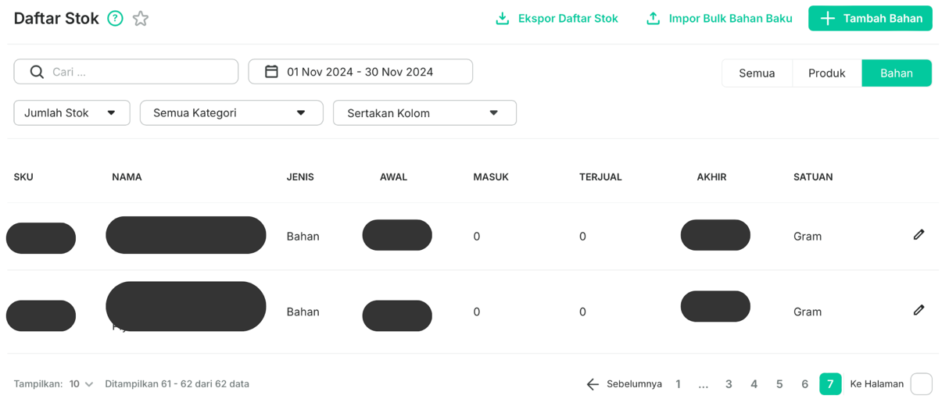
Figure 4 Stock list in the Majoo system

    - Stock Production Framework
After manually recording the data on the spreadsheet, it will be transferred to the Majoo system. This includes inputting the raw materials used in the DIY kits and adding each DIY kit variant as a product in the system. The stock production framework will serve as a template or format for the formulas or recipes of each DIY kit type. This will help simplify operations for AT Studio by making it easier to calculate the raw materials used in all production activities throughout the month.

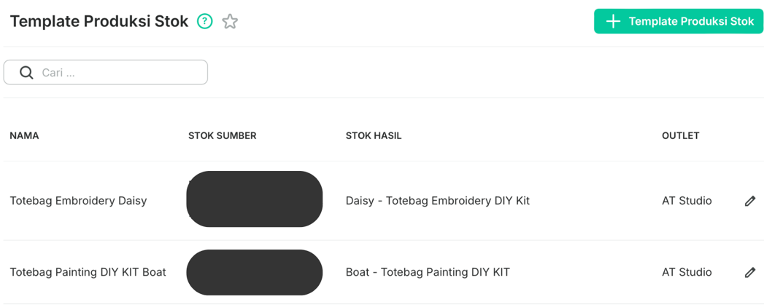
Figure 5 Stock production framework template
    - Stock Production List
After creating the template or format for the formulas in the stock production framework, the next step is similar to “cooking” the formulas that have been made. This stage will be applied to determine how many types of DIY kits have been produced during the month, and the details will be registered through the stock production list.

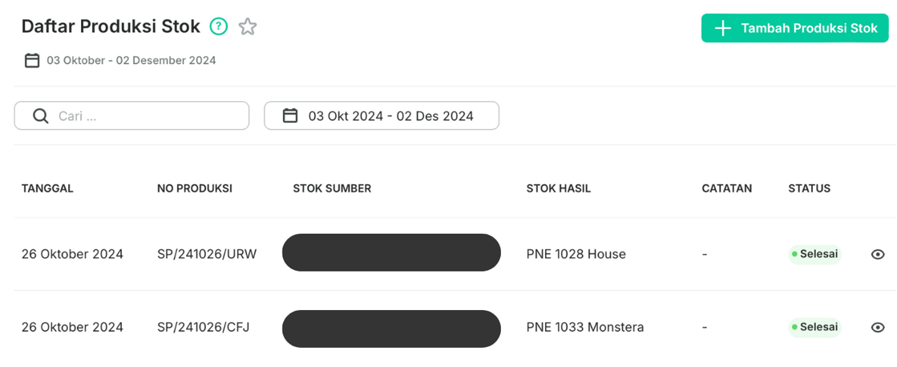
Figure 6 Stock production list

    - Staff Training
After the implementation has been carried out, the author will create user guidelines to help direct the staff in producing and recording stock in the Majoo system. The author has already conducted a presentation, followed by real-time practice, allowing staff to ask question directly if there any steps that are confusing.

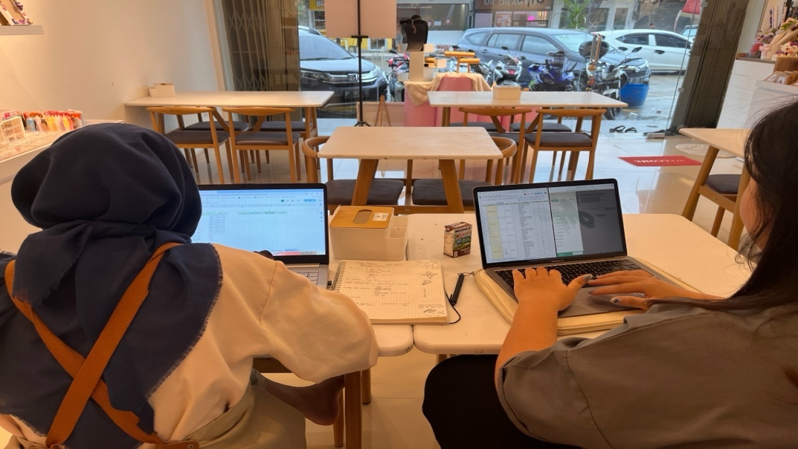
Figure 7 Staff training at AT Studio

- Discussion
After the entire implementation process of activities with AT Studio has been carried out, the operational activities, especially for production and inventory tracking, run smoothly with a workflow that facilitates user movement and minimizes human error. After conducting training for the staff, the strategy for manual product stock recording here continues to be discussed to minimize misunderstandings in recording, and it is designed in such a way that every user who will take over the inventory tracking section will not be confused with the new system. From the initial stage, such as manual stock recording to the product stock list, this has reduced production delays by about 50%. Inventory monitoring can also be accessed in real-time. The accuracy of the data after matching the manual records and the Majoo system records has reached 80%.

- Conclusions
All implementation activities with AT Studio partners show positive results, after the implementation of detailed product stock recording and the accuracy of stock data recording also show positive results. This implementation also made the workflow of inventory tracking effective and efficient, thereby reducing delays in producing finished stock for each DIY Kit variant. Overall, the results of this implementation process for AT Studio successfully provided solutions to the problems faced by the partners and achieved the set goals, and this activity also made an important contribution to the operational activities of AT Studio.

References
Agboola, F. F., Malgwi, Y. M., Mahmud, M. A., & Oguntoye, J. P. (2022). Development of a Web-Based Platform for Automating an Inventory Management of a Small and Medium Enterprise. Fudma : Journal of Sciences, 6(5), 57–65. https://doi.org/https://doi.org/10.33003/fjs-2022-0605-1064
Harjanti, T. W. (2024). Decision Support System for Selecting Point of Sale Applications Using Aras and Roc Approaches. Teknoinfo, 18(1), 160–172. https://doi.org/https://doi.org/10.33003/fjs-2022-0605-1064
Pasaribu, J. S. (2021). Perancangan Sistem Informasi Berbasis Web Pengelolaan Inventaris Aset Kantor di PT. Mpm Finance Bandung. Ilmiah Teknologi Infomasi Terapan, 7(3), 229–241. https://doi.org/https://doi.org/10.33197/jitter.vol7.iss3.2021.655
Putra, A., Jasmine, I., & Yusuf, M. (2023). Pengembangan Inventori dan QR Code untuk Efisiensi Waktu Pemesanan Menu di Kedai Wanama. Scientia Sacra: Jurnal Sains, Teknologi Dan Masyarakat, 3(2), 81–94.
Putra, C. R. K., Rohman, M. Z., & Cahyono, B. (2024). Implementation of Web Inventory Tracking and Monitoring for PT Sucofindo Samarinda Branch. Aplikasi Teknik Dan Pengabdian Masyarakat, 8(4), 123–130. https://doi.org/https://doi.org/10.12345/je.v8i4.103
Sgarbossa, F., Grosse, E. H., Neumann, W. P., Battini, D., & Glock, C. H. (2020). Human factors in production and logistics systems of the future. Annual Reviews in Control, 49, 295–305. https://doi.org/https://doi.org/10.1016/j.arcontrol.2020.04.007
Siskawati, E., Syaputra, H., & Zahara. (2024). The Role of Collaboration and Digital Technology in Supply Chain Management in Micro Enterprises. Economics, Business, Accounting & Society Review, 3(1), 11–19. https://doi.org/https://doi.org/10.55980/ebasr.v3i1.116
Sudiantini, D., Irvana, N., & W, M. B. F. (2023). Peran supply chain management dalam sistem produksi dan operasi perusahaan. Ekonomi Akuntansi, Manajemen, 2(6), 54–66. https://doi.org/https://doi.org/10.572349/mufakat.v2i6.1234
Sugiyono. (2019). Metode Penelitian Kuantitatif, Kualitatif, R&D. Alfabeta.
Zhang, S., Huang, K., & Yuan, Y. (2021). Spare parts inventory management: A literature review. Sustainability, 13(5), 1–23. https://doi.org/https://doi.org/10.3390/su13052460

