STATEMENT LETTER

Name : Miftakhul Jannah
Institution : Universitas Negeri Surabaya
Institution Address : Jl. Lidah Wetan, Surabaya 60213
Mailing Address : Jl. Kenjeran 307 Surabaya 60134
E-mail : miftakhuljannah@unesa.ac.id
Mobile Phone : 08123594795
Article Title : Dapatkah Relaksasi Otogenik Menurunkan Kecemasan Atlet Menembak ?

- Author and co-author have sufficiently participated in this article’s writing so the article can be accountable to the public.
- All of the authors have reviewed the final version of the manuscript and agreed to publish this manuscript.
- This text has not been published in is similar or the same form in other journals or any magazines and is not processed in any other journal or any magazine.
- This text is the authors’ original work and plagiarism free; if later found indications of plagiarism, the authors are willing to accept sanctions per prevailing regulations.
- This text is accompanied by a copy of the ethical clearance statement*
- The manuscript was sent to the Journal of Psychological Perspective will not be withdrawn before it was decided whether the manuscript is accepted or rejected.

Surabaya, 14 – 11- 2021

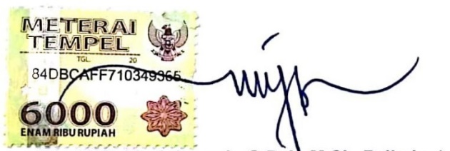  First Author  (Miftakhul Jannah) |  | Co-author (2)  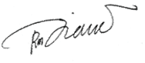  (Diana Rahmasari)
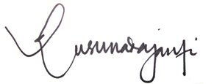  Co-author (3)  (Damajanti Kusuma Dewi) |  | 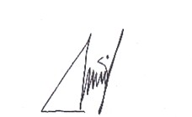  Co-author (4)  (Umi Anugerah Izzati)

Note:
* Devoted to experimental research involving human and/animals samples
- Biodata is filled by the corresponding author only
- All Writers who contributed to this paper are required to provide consent signatures
-Signature with 6000 stamped listed to the only corresponding author

